Chapter 7, Problem 15.

Find the time constant for each of the circuits in Fig. 7.95.

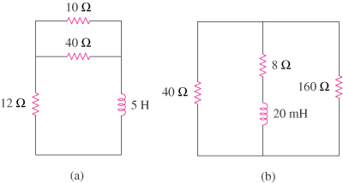
48 Ω
2 Ω

Figure 7.95
For Prob. 7.15.

